**Part A: Calculate Shipping Charge**

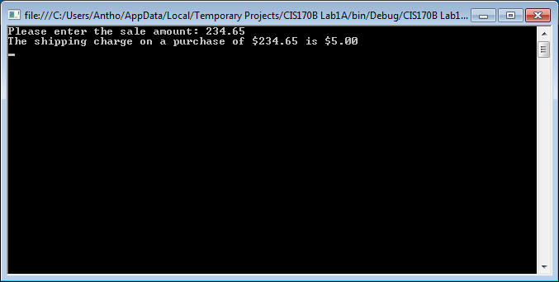

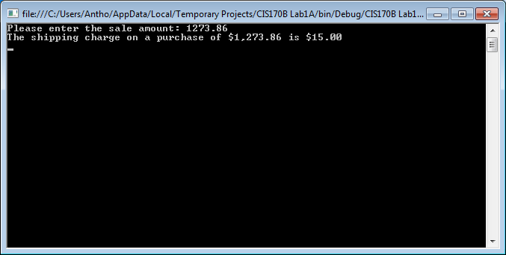

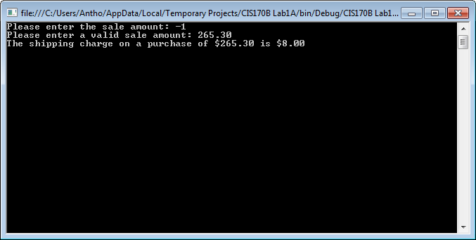

// ---------------------------------------------------------------

// Programming Assignment: LAB2A

// Developer: Anthony Meunier

// Date Written: 7/18/2014

// Purpose: Calculate Shipping Charge

// ---------------------------------------------------------------

using System;

using System.Collections.Generic;

using System.Linq;

using System.Text;

using System.Threading.Tasks;

namespace CIS170B_Lab1A

{

class Program

{

static void Main(string[] args)

{

//declare variables

double saleAmount, shippingCost;

//get the input

Console.Write("Please enter the sale amount: ");

saleAmount = Convert.ToDouble(Console.ReadLine());

//calculations and display output

if (saleAmount < 0)

{

Console.Write("Please enter a valid sale amount: ");

saleAmount = Convert.ToDouble(Console.ReadLine());

if (saleAmount > 5000)

{

shippingCost = 20;

Console.WriteLine("The shipping charge on a purchase of " + saleAmount.ToString("C") + " is " + shippingCost.ToString("C"));

}

else if (saleAmount >= 1000.01 && saleAmount <= 5000)

{

shippingCost = 15;

Console.WriteLine("The shipping charge on a purchase of " + saleAmount.ToString("C") + " is " + shippingCost.ToString("C"));

}

else if (saleAmount >= 500.01 && saleAmount <= 1000)

{

shippingCost = 10;

Console.WriteLine("The shipping charge on a purchase of " + saleAmount.ToString("C") + " is " + shippingCost.ToString("C"));

}

else if (saleAmount >= 250.01 && saleAmount <= 500)

{

shippingCost = 8;

Console.WriteLine("The shipping charge on a purchase of " + saleAmount.ToString("C") + " is " + shippingCost.ToString("C"));

}

else if (saleAmount == 0 && saleAmount <= 250)

{

shippingCost = 5;

Console.WriteLine("The shipping charge on a purchase of " + saleAmount.ToString("C") + " is " + shippingCost.ToString("C"));

}

}

else if (saleAmount > 5000)

{

shippingCost = 20;

Console.WriteLine("The shipping charge on a purchase of " + saleAmount.ToString("C") + " is " + shippingCost.ToString("C"));

}

else if (saleAmount >= 1000.01 && saleAmount <= 5000)

{

shippingCost = 15;

Console.WriteLine("The shipping charge on a purchase of " + saleAmount.ToString("C") + " is " + shippingCost.ToString("C"));

}

else if (saleAmount >= 500.01 && saleAmount <= 1000)

{

shippingCost = 10;

Console.WriteLine("The shipping charge on a purchase of " + saleAmount.ToString("C") + " is " + shippingCost.ToString("C"));

}

else if (saleAmount >= 250.01 && saleAmount <= 500)

{

shippingCost = 8;

Console.WriteLine("The shipping charge on a purchase of " + saleAmount.ToString("C") + " is " + shippingCost.ToString("C"));

}

else if (saleAmount == 0 && saleAmount <= 250)

{

shippingCost = 5;

Console.WriteLine("The shipping charge on a purchase of " + saleAmount.ToString("C") + " is " + shippingCost.ToString("C"));

}

//keep console display open

Console.ReadLine();

}

}

}

**Part B: TV Channel to Call Sign**

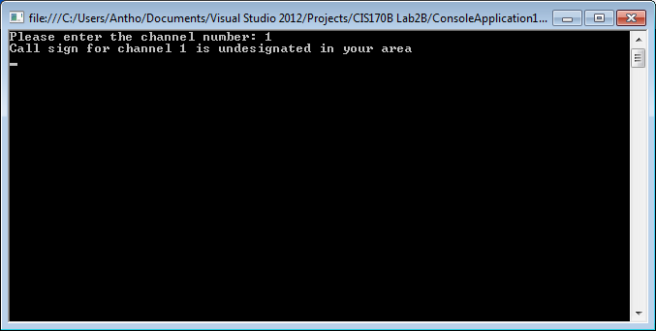

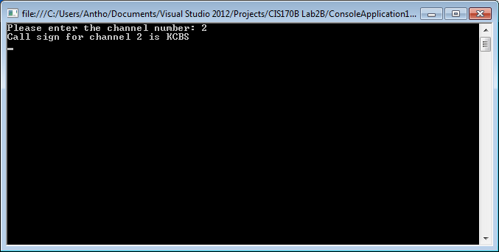

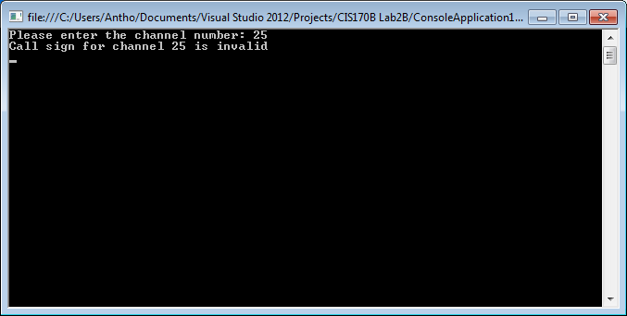

// ---------------------------------------------------------------

// Programming Assignment: LAB2B

// Developer: Anthony Meunier

// Date Written: 7/18/2014

// Purpose: TV Channel to Call Sign

// ---------------------------------------------------------------

using System;

using System.Collections.Generic;

using System.Linq;

using System.Text;

using System.Threading.Tasks;

namespace CIS170BLab2B

{

class Program

{

static void Main(string[] args)

{

//declare variables

int channel;

string callsign;

//get input

Console.Write("Please enter the channel number: ");

channel = Convert.ToInt32(Console.ReadLine());

//calculations

switch (channel)

{

case 1:

callsign = "undesignated in your area";

break;

case 2:

callsign = "KCBS";

break;

case 3:

callsign = "undesignated in your area";

break;

case 4:

callsign = "KNBC";

break;

case 5:

callsign = "KTLA";

break;

case 6:

callsign = "KDOC";

break;

case 7:

callsign = "KABC";

break;

case 8:

callsign = "HSN";

break;

case 9:

callsign = "KCAL";

break;

case 10:

callsign = "QVC";

break;

default:

callsign = "invalid";

break;

}

//display output

Console.WriteLine("Call sign for channel " + channel + " is {0}", callsign);

//keep console display open

Console.ReadLine();

}

}

}